Documentation for the meshfill graphics method

Introduction
The meshfill graphics method allows display of generalized grids through the vcs interface

Description
Plotting an array on a generalized grid requires at least 3 arguments:
- The data array to be plotted
- The “mesh” representing the grid cell boundaries (in y/x space)
- The meshfill graphics method object
On its simplest form, plotting the array A on the generalized mesh M using the meshfill method m would be:
import vcs
x=vcs.init()
x.plot(A,M,m)

The data array

Description
Any Numeric/MA/MV array can be used, but its last dimension will be used as the one representing the 2D spatial dimension.
The array can have additional leading extra dimensions. Such as time, level, depth, etc…

Examples of valid arrays shapes
A.shape= (100,) # generalized mesh containing 100 cells
A.shape=(2,100) # 1 extra leading dimension ( used for animations, by default the first plan is plotted, i.e. A[0,:] )
A.shape=(10,25,100) # 2 extra leading dimensions (first plan plotted A[0,0,:], second one: A[0,1,:], etc…)

Case of a generalized grid defined on i, j indices:
If your data are defined on i, j indices for example Aij.shape=(10,10), i.e. 100 cells to be used for the mesh, then you must first reshape your data as follow:
A=MV.reshape(A,(100,))
Or
A=MV.ravel(A), since there is no leading dimension here

The mesh array

Description
The mesh description is also an array, it is on the form: (nelements,2,nvertices) where:
- ncell represents the number of elements constituting the mesh.
- 2: represent the Y and X spatial dimension
- nvertices: represent the number of vertices of each mesh element
Note: if your mesh does not have the same number of vertices per element then nvertices should be the maximm number of vertices that an element can have, and unused values of vertices should then be set to missing (1.E20 for a Numeric object, or via associated mask for MA and MV)

Examples
Let’s use for example a mesh constituted of 100 quadrilaterals (or elements).
The mesh array (M) should be dimensioned : (100,2,4)
Now let’s look at how the mesh for the i^{th} quadrilateral (element) (figure 1)
Xi1,Yi1
Xi2,Yi2
Xi3,Yi3
Xi4,Yi4
Y
X
Figure 1: ith element of data and mesh

For the i^{th} element the the data array (A[i]), the mesh element m=M[i] is 2 dimensional
m[0] has a length of 4 and represent the Y values of the vertices CONSECUTIVELY
m[1] has a length of 4 and represents the X values of the vertices CONSECUTIVELY

From figure 1: M[i,0]=[Yi1,Yi2,Yi3,Yi4] and M[i,1]=[Xi1,Xi2,Xi3,Xi4]

Note: It is fundamental that the vertices are stored consecutively, the direction does not matter, see figure 2 for an example of bad storage
Xi1,Yi1
Xi2,Yi2
Xi3,Yi3
Xi4,Yi4
Y
X
Figure 2: mesh array with vertices stored non consecutively
Finally the mesh array should have the same shape as the data array with the 2 additional trailing dimensions
i.e. if A is shaped (12,100) and have a maximum of n vertices per element M should be shaped (12,100,2,n)

Meshfill graphics method object
The mesh graphics method object is very similar to the isofill graphics method
It is created as follow:
import vcs
x=vcs.init()
mesh=x.createmeshfill(‘name’)
Note: ‘name’ must be unique if the mesh you want is in your initial.attributes file or has already been created during your python session you can get it again by executing: mesh=x.getmeshfill(‘mymesh’)
In order to see the settable attributes of the mesh graphics method and their values do:
mesh.list()
Let’s now examine each of this attributes
datawc_x1, datawac_x2, datawc_y1 and datawc_y2: these define the domain on which you want to draw your mesh, area outside of this domain will be clipped or not drawn
levels: the range to use for the colors, e.g: [10,20,30,40] or [[10,20],[20,30],[40,50]]
fillareacolors: the color indices to use for each range, e.g [16,18,20]
fillareastyle: style of filling: ‘solid’, ‘hatch’ or ‘pattern’
fillareaindices: indices of pattern to use for each range, e.g, [2,4,5]
ext_1: add an arrow at the begining of the range (same as passing -1.e20 for the first value of levels)
ext_2: add an arrow at the end of the range (same as passing 1.e20 as the las value of levels)
mesh: 0/1 draws the a line connecting the vertices
missing: color of the missing value (default is white=transparent)
projection: type of projection for the graph (really only for the lat/lon graphs, assumes value are in degrees)
x/ytics1/2: values to use for ticks marks 1/2 (See templatedocumentation for more explanation on tick marks and labels)
x/yticlabels1/2: labels to use for ticks1/2 (see template documentation)
x/yprojection: projection for x/y axis (linear,log,exp,area_weights)

Examples:

Simple example: 2 quadrilaterals and a triangle

See Figure 3 for result

#!/usr/bin/env python

"""Program to draw the figure 3
Drawing data on a mesh made of 2 quadrilateral and a triangle
"""
# import the necessary module
import MV #to manipulate arrays
import vcs # to plot

## First create the array with the 3 elements
A=MV.array([13.,21.,32.])

## Now let's create the mesh,
## for more clarity will start with an empty mesh array (M)
## and fill each part one at a time
## The maximum number of vertices is 4, therefore:
M=MV.zeros((3,2,4),typecode=MV.Float)
## 3 because A has element,
## 2 becuase with need coordinate on the y and x direction,
## and 4 because the maximum number of vertices is 4

## First polygon 1 (quadrilateral)
## Y coordinates
M[0,0]=MV.array([4.,.5,-5.5,0.])
## X coordinates:
M[0,1]=MV.array([-6.,-7.5,-4.5,0.])
## Second polygon (triangle)
M[1,0]=MV.array([0.,1.,4.,1.E20]) # the last is set to missing because unused
M[1,1]=MV.array([0.,6.,-6,1.e20]) # the last is set to missing because unused
## Third polygon (quadrilateral)
M[2,0]=MV.array([0.,-5.5,-5.,1])
M[2,1]=MV.array([0.,-4.5,3,6])

## Now let's plot it
# first create the canvas
x=vcs.init()

## Now let's create the meshfill graphics method
m=x.createmeshfill('figure3')

# Let's set the world coordinate to go from -6 to 5 in Y
m.datawc_y1=-6.
m.datawc_y2=5.
# Let's set the world coordinate to go from -8 to 6.5 in X
m.datawc_x1=-8.
m.datawc_x2=6.5

# let's set the levels to less than 20, between 20 and 30, more than 30
m.levels=[-1.e20,20.,30,1.e20]

# Let's set the color to blue (color 244),green (243) and red (242)
m.fillareacolors=[244,243,242]

# let's draw the mesh around the polygons
m.mesh='y'

# Now let's plot it
x.plot(A,M,m)

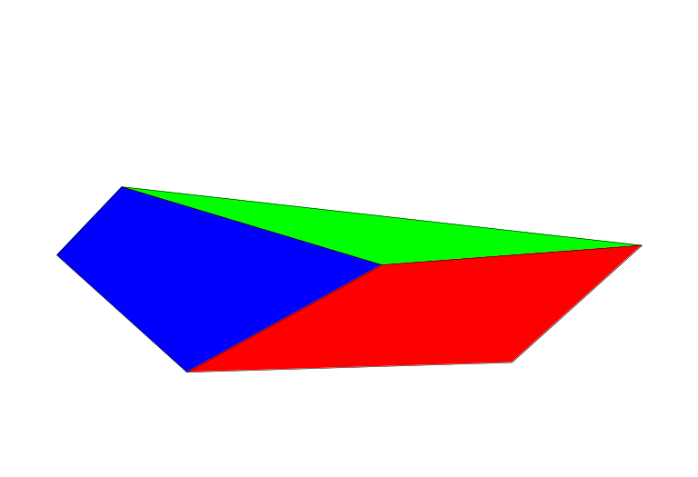
Figure 3: Simple mesh

Wrapping the data
Results on figure 4
#!/usr/bin/env python

"""Program to draw the figure 3
Drawing data on a mesh made of 2 quadrilateral and a triangle
"""
# import the necessary module
import MV #to manipulate arrays
import vcs # to plot

## First create the array with the 3 elements
A=MV.array([13.,21.,32.])

## Now let's create the mesh,
## for more clarity will start with an empty mesh array (M)
## and fill each part one at a time
## The maximum number of vertices is 4, therefore:
M=MV.zeros((3,2,4),typecode=MV.Float)
## 3 because A has element,
## 2 becuase with need coordinate on the y and x direction,
## and 4 because the maximum number of vertices is 4

## First polygon 1 (quadrilateral)
## Y coordinates
M[0,0]=MV.array([4.,.5,-5.5,0.])
## X coordinates:
M[0,1]=MV.array([-6.,-7.5,-4.5,0.])
## Second polygon (triangle)
M[1,0]=MV.array([0.,1.,3.5,4.]) # the last is set to missing because unused
M[1,1]=MV.array([0.,6.,3.,-6.]) # the last is set to missing because unused
M[1,0]=MV.array([0.,1.,4.,1.E20]) # the last is set to missing because unused
M[1,1]=MV.array([0.,6.,-6.,1.E20]) # the last is set to missing because unused
## Third polygon (quadrilateral)
M[2,0]=MV.array([0.,-5.5,-5.,1])
M[2,1]=MV.array([0.,-4.5,3,6])
#M=MV.masked_greater(M,500)
## Now let's plot it
# first create the canvas
x=vcs.init()

## Now let's create the meshfill graphics method
m=x.createmeshfill('figure3')

# Let's set the world coordinate to go from -60 to 50 in Y
m.datawc_y1=-60
m.datawc_y2=50
# Let's set the world coordinate to go from -80 to 65 in X
m.datawc_x1=-80
m.datawc_x2=65

# let's set the levels to less than 20, between 20 and 30, more than 30
m.levels=[-1.e20,20.,30,1.e20]

# Let's set the color to blue (color 244),green (243) and red (242)
m.fillareacolors=[244,243,242]

# Let's set it to pattern
m.fillareastyle='hatch'
m.fillareaindices=[13,14,18]
# let's draw the mesh around the polygons
m.mesh='y'

# let's assume that this particular mesh wraps around
# let's say every 12 on Y and every 15 on X
m.wrap=[12,15.]

# Now let's plot it
x.plot(A,M,m)

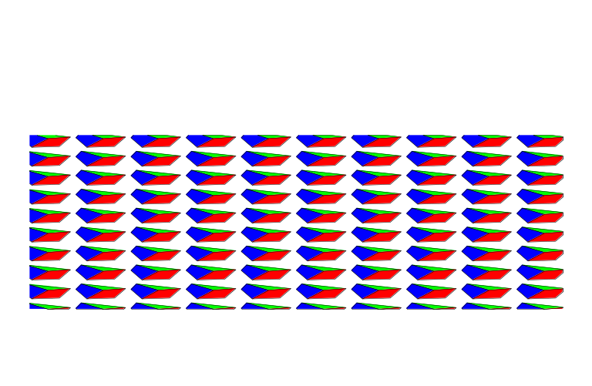
Figure 4: wrapping

Using real data: plotting an OCMIP model bathymetry
The necessary Netcdf file can be obtained at cdat.sf.net, it is stored in the cdat_tutorials_data.tgz file

See figure 5 for the result

#!/usr/bin/env python

## import the necessary modules
import cdms
import vcs
import MV
import Numeric

TESTDIR = '../cdat_tutorial_data/'
TEMPDIR = './'

## Now let's read some ocena data
## We need to first reconstruct the mesh.
fnm=TESTDIR+'OCMIP.nc'
f=cdms.open(fnm)
print f.variables.keys()

# The following function will generate the mesh
def makeOCMIPMesh(blon,blat):
## First make sure values are between 0 and 360
blon=Numeric.where(Numeric.greater(blon,360.),blon-360.,blon)
blon=Numeric.where(Numeric.less(blon,0.),blon+360.,blon)
## Get the shape and makes the shape for the Mesh out of it
sh=list(blon.shape)
sh=sh[-2:]
sh.insert(0,4)
sh.insert(0,2)
## Creates the Mesh object (with zeros only at first)
M=Numeric.zeros(sh,Numeric.Float)
## List that tells wich index to get for each vertice
c=[[1,1],[0,1],[0,0],[1,0]]
for i in range(4):
j=c[i][0]
k=c[i][1]
M[0,i]=blat[j,k]
M[1,i]=blon[j,k]
# Now reorder the Mesh so that the 2,4 are last
reorder=(2,3,0,1)
M=Numeric.transpose(M,reorder)
val=100
# Finally some grid cells go over the dateline , so we need to reset them by adding 360 or removing 360
for k in range(3):
M[:,:,1,k+1]=Numeric.where(Numeric.less( M[:,:,1,k]-M[:,:,1,k+1],-val),M[:,:,1,k+1]-360,M[:,:,1,k+1])
M[:,:,1,k+1]=Numeric.where(Numeric.greater(M[:,:,1,k]-M[:,:,1,k+1], val),M[:,:,1,k+1]+360,M[:,:,1,k+1])
M[:,:,1,k+1]=Numeric.where(Numeric.less( M[:,:,1,k]-M[:,:,1,k+1],-val),M[:,:,1,k+1]-360,M[:,:,1,k+1])
return cdms.asVariable(M)

## Now let's retrieve the data (bathmyetry)
bathy=f('BATHY')

## Let's retrieve the bounds in order to generate the mesh
blat=f('bounds_lat').filled()
blon=f('bounds_lon').filled()

print blat.shape,blon.shape
## And generate the mesh
Mesh=makeOCMIPMesh(blon,blat)

## Let's also retrieve the mask (first depth only)
mask=f('MASK',depth=slice(0,1),squeeze=1)

## we need to invert this mask (1 means valid data at this point)
mask=1.-mask

## Let's apply this mask to the mesh (each vertice), for lon and lat.
for i in range(2):
for j in range(4):
Mesh[:,:,i,j]=MV.masked_where(mask,Mesh[:,:,i,j])

## Let's mask the data where appropriate
bathy=MV.masked_where(mask,bathy)

## Now these data are in x/y, meshfill only accepts 1D array
## We need to reshape the Mesh and the data
sh=Mesh.shape
Mesh=Mesh.astype(MV.Float)
Mesh=MV.reshape(Mesh,(sh[0]*sh[1],2,4))
bathy=MV.ravel(bathy)

## Now let's create the vcs canvas
x=vcs.init()

## Let's create the meshfill method
m=x.createmeshfill('tutotrial_3')

## Let's set the world coordinate to go from -180, to 180
m.datawc_x1=-180.
m.datawc_x2=180.
m.datawc_y1=-90.
m.datawc_y2=90.

## Let's set the wrapping
m.wrap=[0.,360.]

## Let's have some nice latitudes and longitudes
lats_15={-90 : '90S',-75 : '75S',-60 : '60S',-45 : '45S',-30 : '30S',-15 : '15S',
0 : 'Eq',15 : '15N',30 : '30N',45 : '45N',60 : '60N',75 : '75N',90 : '90N',}

lons_30={-180 : '180W',-150 : '150W',-120 : '120W',-90 : '90W',-60 : '60W',-30 : '30W',0 : '0',
30 : '30E',60 : '60E',90 : '90E',120 : '120E',150 : '150E',180 : '180E'}

m.xticlabels1=lons_30
m.yticlabels1=lats_15
m.xticlabels2=lons_30
m.yticlabels2=lats_15

## Let's draw the mesh
m.mesh=1

## Let's set the projection to mollweide
m.projection='mollweide'
## Let's set the projection to robinson
m.projection='robinson'
## Let's set the projection to polar
m.projection='polar'
## Let's set the projection to linear
m.projection='linear'

## Let's set the title and the variable name
bathy.id='Bathymetry'

## And let's draw this, adding the continents on top of it
x.meshfill(bathy,Mesh,m,continents=4)

## Let's save the output
x.postscript('meshfill_tutorial_3.ps')

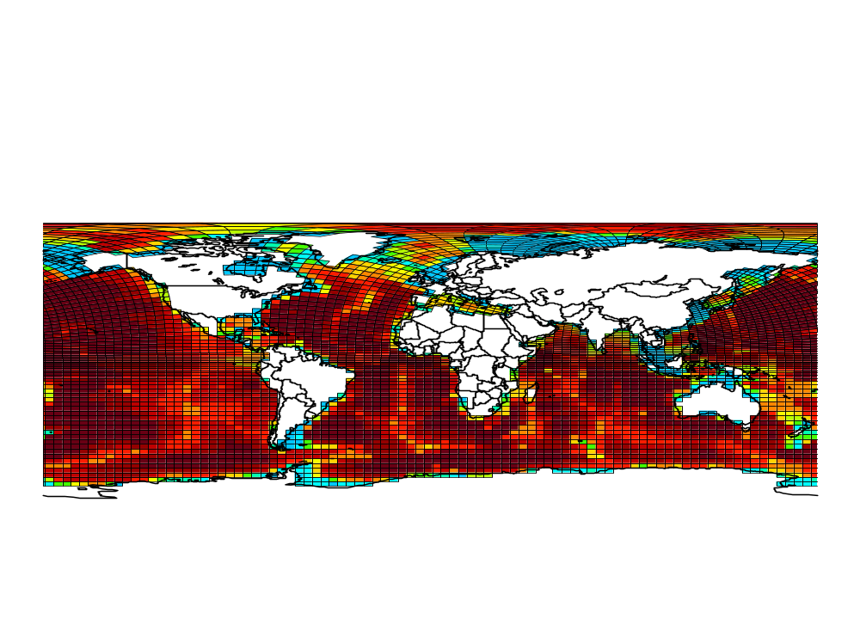
Figure 5: Bathymetry on an OCMIP model grid

